**Computer Architecture I – Programming Assignment**

**Cache Emulator**

The project is written on Java in the IntelliJ IDE and has been posted on GitHub as well.

GitHub link - <https://github.com/darkrishabh/Cache-Emulator>

Java Docs for this project are also supplied within this package. Please open the index.html file in the JavaDocs folder of this package.

Also a demo video can be found here - <http://www.youtube.com/watch?v=ncFrZbK_VPU>

File locations –

* Source Files - Source/src
* JavaDocs - JavaDocs/index.html
* Jar Executable - Jar Executable/Computer Architecture I.jar

Execution –

* Windows:

1. Open Command Prompt
2. Change to the Directory where Jar Executable is.
3. Run the command: *java –jar “Computer Architecture I.jar”*

* Mac/Linux

1. Open Terminal
2. Move to the Directory where Jar Executable it
3. Run the command: *java –jar “Computer Architecture I.jar”*

Testing –

No such Unit Test for the code have been performed, however black box testing was done to ensure cross platform integrity.

On Windows 8.1 with JRE 1.8 – OK

On Macintosh 10.9 with JRE 1.8 – OK

On Macintosh 10.10 with JRE 1.7 – OK

On Linux Ubuntu with JRE 1.8 – OK

Screenshots –

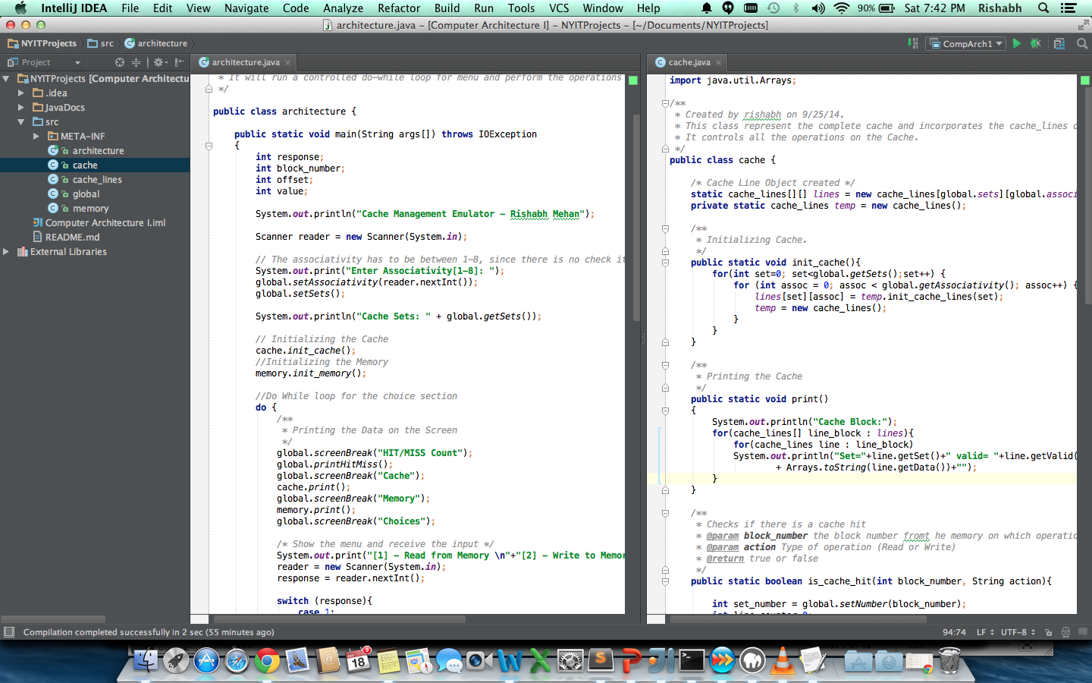

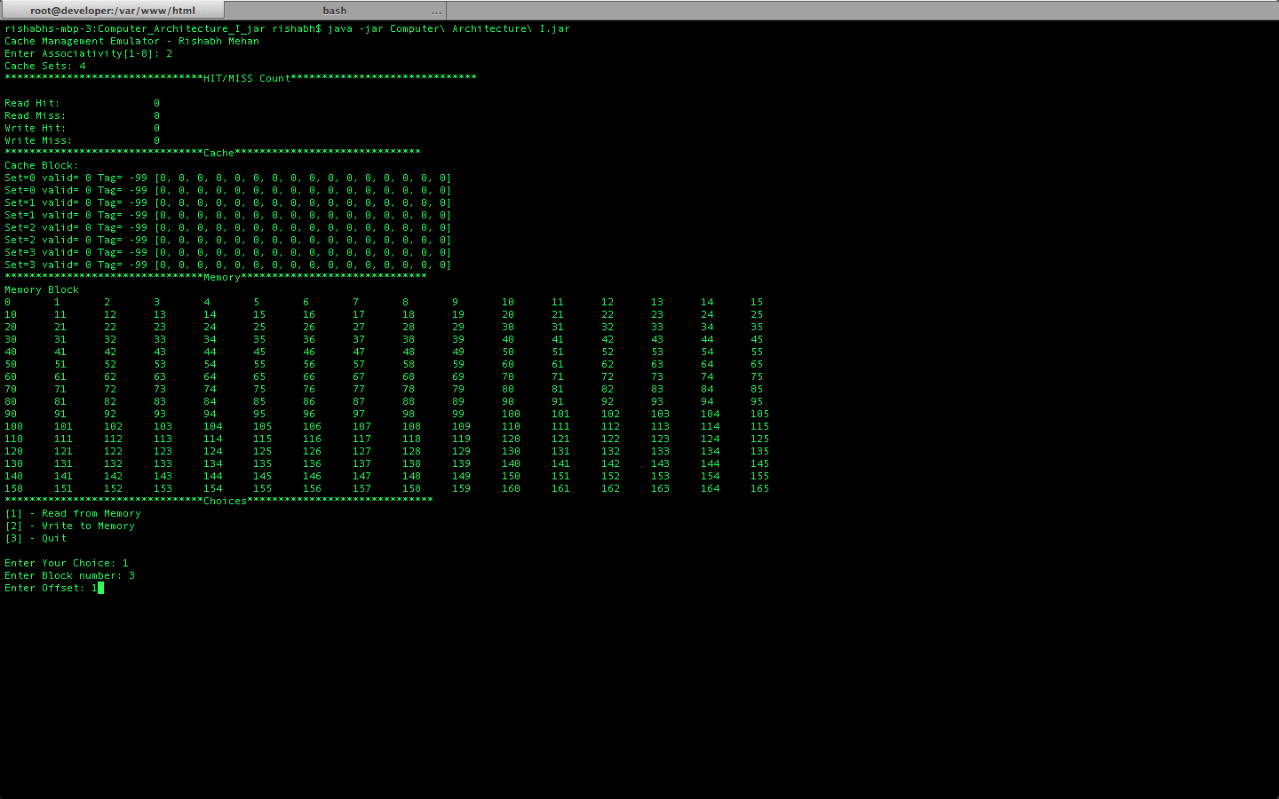

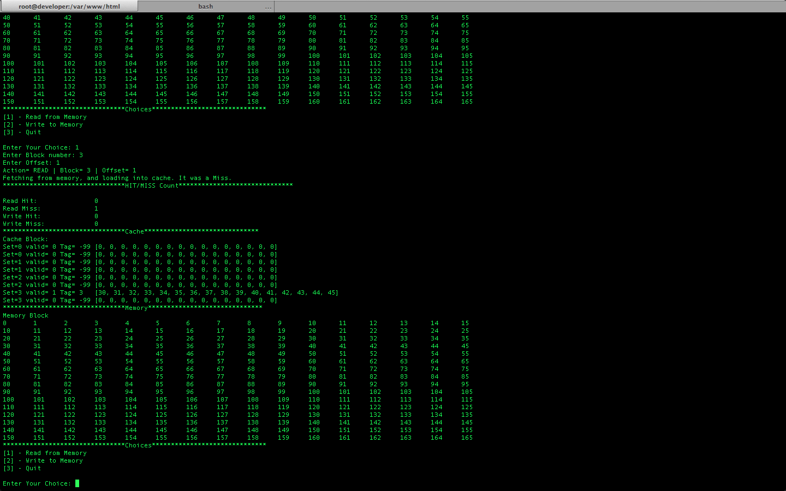

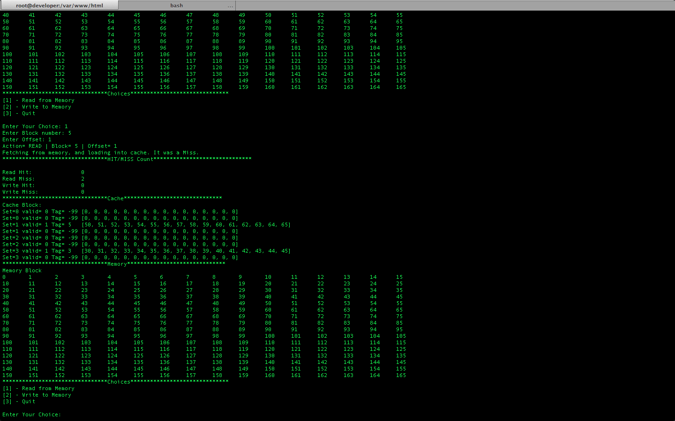

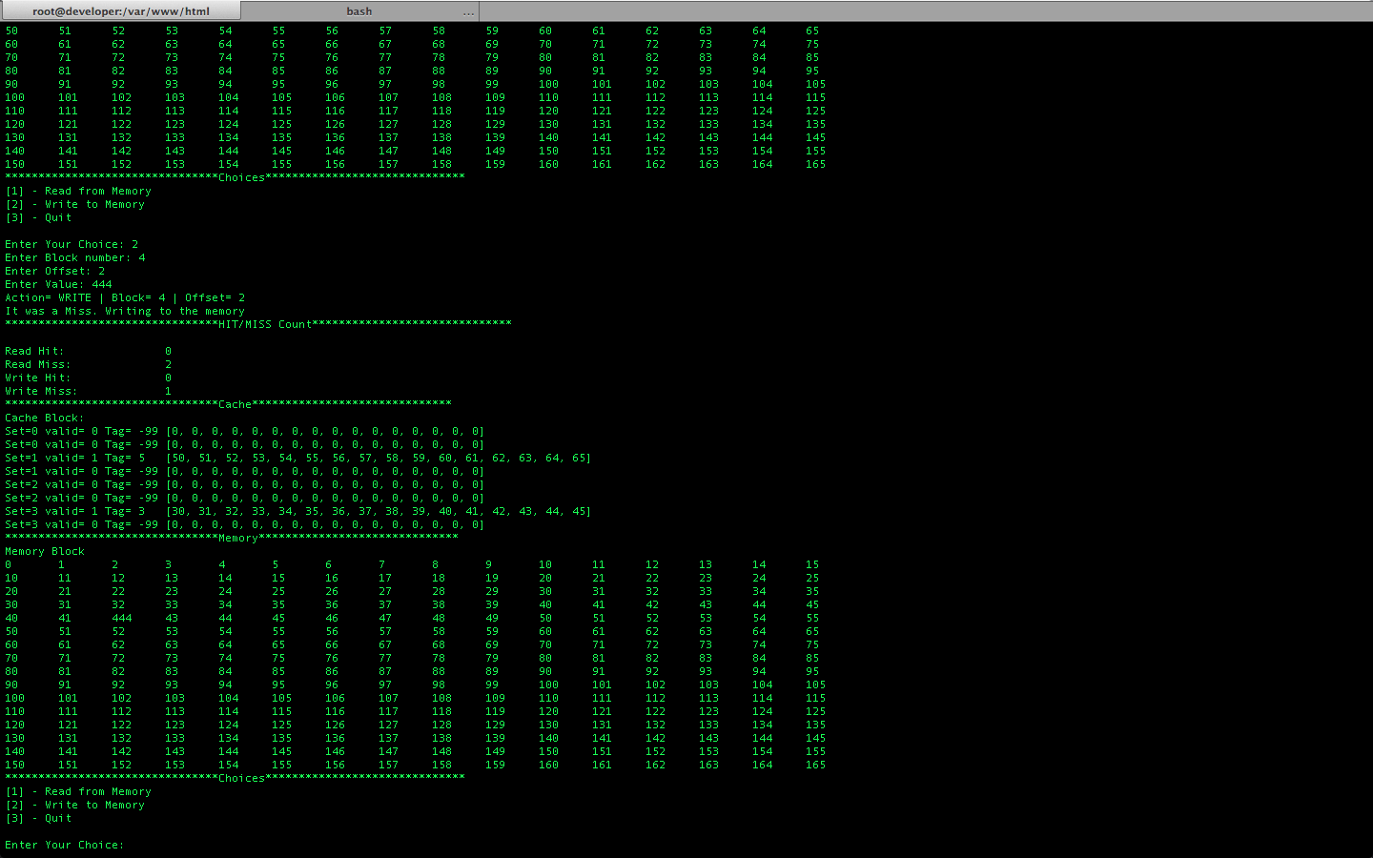

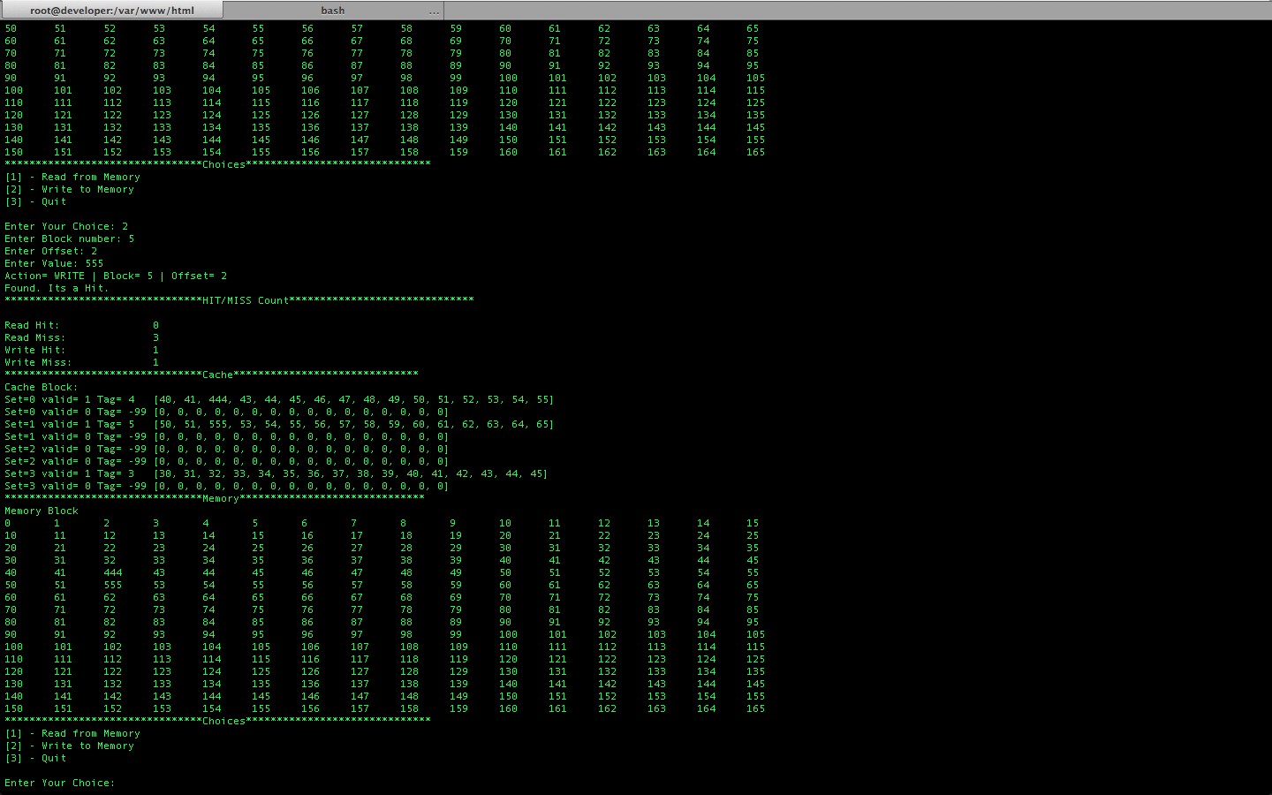

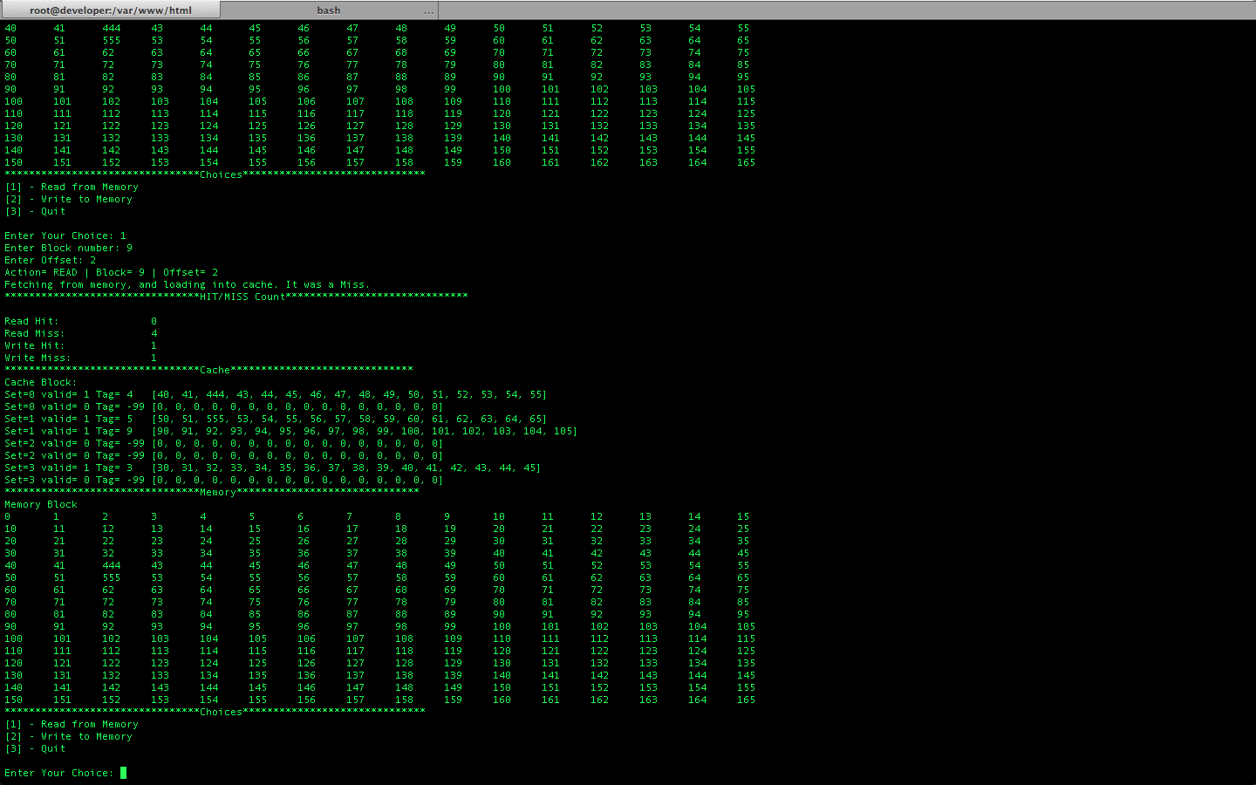

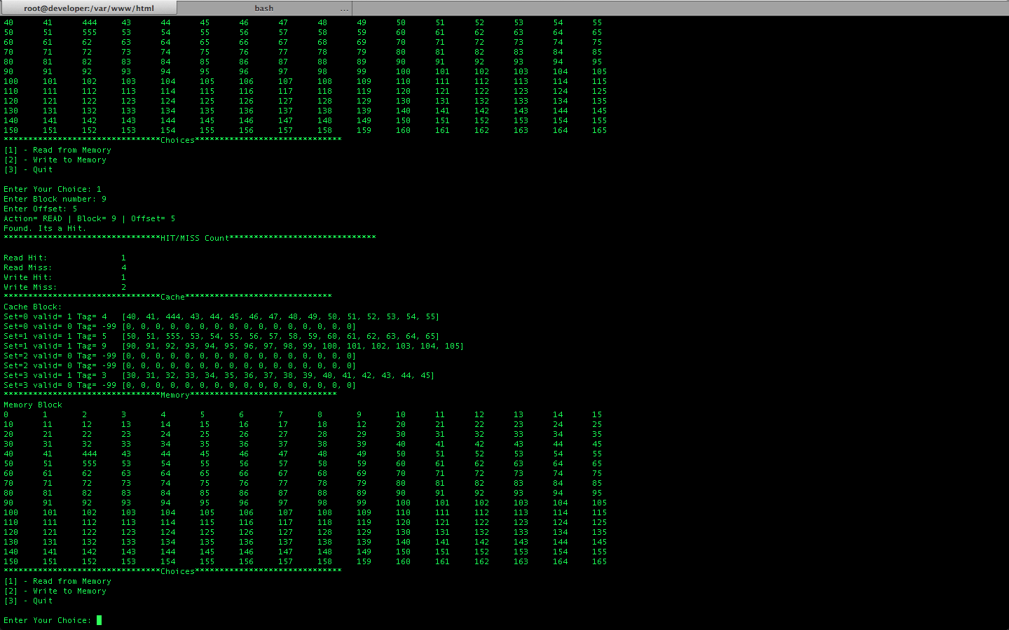

Output Log

rishabhs-mbp-3:Computer_Architecture_I_jar rishabh$ java -jar Computer\ Architecture\ I.jar

Cache Management Emulator - Rishabh Mehan

Enter Associativity[1-8]: 2

Cache Sets: 4

********************************HIT/MISS Count******************************

Read Hit: 0

Read Miss: 0

Write Hit: 0

Write Miss: 0

********************************Cache******************************

Cache Block:

Set=0 valid= 0 Tag= -99 [0, 0, 0, 0, 0, 0, 0, 0, 0, 0, 0, 0, 0, 0, 0, 0]

Set=0 valid= 0 Tag= -99 [0, 0, 0, 0, 0, 0, 0, 0, 0, 0, 0, 0, 0, 0, 0, 0]

Set=1 valid= 0 Tag= -99 [0, 0, 0, 0, 0, 0, 0, 0, 0, 0, 0, 0, 0, 0, 0, 0]

Set=1 valid= 0 Tag= -99 [0, 0, 0, 0, 0, 0, 0, 0, 0, 0, 0, 0, 0, 0, 0, 0]

Set=2 valid= 0 Tag= -99 [0, 0, 0, 0, 0, 0, 0, 0, 0, 0, 0, 0, 0, 0, 0, 0]

Set=2 valid= 0 Tag= -99 [0, 0, 0, 0, 0, 0, 0, 0, 0, 0, 0, 0, 0, 0, 0, 0]

Set=3 valid= 0 Tag= -99 [0, 0, 0, 0, 0, 0, 0, 0, 0, 0, 0, 0, 0, 0, 0, 0]

Set=3 valid= 0 Tag= -99 [0, 0, 0, 0, 0, 0, 0, 0, 0, 0, 0, 0, 0, 0, 0, 0]

********************************Memory******************************

Memory Block

0 1 2 3 4 5 6 7 8 9 10 11 12 13 14 15

10 11 12 13 14 15 16 17 18 19 20 21 22 23 24 25

20 21 22 23 24 25 26 27 28 29 30 31 32 33 34 35

30 31 32 33 34 35 36 37 38 39 40 41 42 43 44 45

40 41 42 43 44 45 46 47 48 49 50 51 52 53 54 55

50 51 52 53 54 55 56 57 58 59 60 61 62 63 64 65

60 61 62 63 64 65 66 67 68 69 70 71 72 73 74 75

70 71 72 73 74 75 76 77 78 79 80 81 82 83 84 85

80 81 82 83 84 85 86 87 88 89 90 91 92 93 94 95

90 91 92 93 94 95 96 97 98 99 100 101 102 103 104 105

100 101 102 103 104 105 106 107 108 109 110 111 112 113 114 115

110 111 112 113 114 115 116 117 118 119 120 121 122 123 124 125

120 121 122 123 124 125 126 127 128 129 130 131 132 133 134 135

130 131 132 133 134 135 136 137 138 139 140 141 142 143 144 145

140 141 142 143 144 145 146 147 148 149 150 151 152 153 154 155

150 151 152 153 154 155 156 157 158 159 160 161 162 163 164 165

********************************Choices******************************

[1] - Read from Memory

[2] - Write to Memory

[3] - Quit

Enter Your Choice: 1

Enter Block number: 3

Enter Offset: 1

Action= READ | Block= 3 | Offset= 1

Fetching from memory, and loading into cache. It was a Miss.

********************************HIT/MISS Count******************************

Read Hit: 0

Read Miss: 1

Write Hit: 0

Write Miss: 0

********************************Cache******************************

Cache Block:

Set=0 valid= 0 Tag= -99 [0, 0, 0, 0, 0, 0, 0, 0, 0, 0, 0, 0, 0, 0, 0, 0]

Set=0 valid= 0 Tag= -99 [0, 0, 0, 0, 0, 0, 0, 0, 0, 0, 0, 0, 0, 0, 0, 0]

Set=1 valid= 0 Tag= -99 [0, 0, 0, 0, 0, 0, 0, 0, 0, 0, 0, 0, 0, 0, 0, 0]

Set=1 valid= 0 Tag= -99 [0, 0, 0, 0, 0, 0, 0, 0, 0, 0, 0, 0, 0, 0, 0, 0]

Set=2 valid= 0 Tag= -99 [0, 0, 0, 0, 0, 0, 0, 0, 0, 0, 0, 0, 0, 0, 0, 0]

Set=2 valid= 0 Tag= -99 [0, 0, 0, 0, 0, 0, 0, 0, 0, 0, 0, 0, 0, 0, 0, 0]

Set=3 valid= 1 Tag= 3 [30, 31, 32, 33, 34, 35, 36, 37, 38, 39, 40, 41, 42, 43, 44, 45]

Set=3 valid= 0 Tag= -99 [0, 0, 0, 0, 0, 0, 0, 0, 0, 0, 0, 0, 0, 0, 0, 0]

********************************Memory******************************

Memory Block

0 1 2 3 4 5 6 7 8 9 10 11 12 13 14 15

10 11 12 13 14 15 16 17 18 19 20 21 22 23 24 25

20 21 22 23 24 25 26 27 28 29 30 31 32 33 34 35

30 31 32 33 34 35 36 37 38 39 40 41 42 43 44 45

40 41 42 43 44 45 46 47 48 49 50 51 52 53 54 55

50 51 52 53 54 55 56 57 58 59 60 61 62 63 64 65

60 61 62 63 64 65 66 67 68 69 70 71 72 73 74 75

70 71 72 73 74 75 76 77 78 79 80 81 82 83 84 85

80 81 82 83 84 85 86 87 88 89 90 91 92 93 94 95

90 91 92 93 94 95 96 97 98 99 100 101 102 103 104 105

100 101 102 103 104 105 106 107 108 109 110 111 112 113 114 115

110 111 112 113 114 115 116 117 118 119 120 121 122 123 124 125

120 121 122 123 124 125 126 127 128 129 130 131 132 133 134 135

130 131 132 133 134 135 136 137 138 139 140 141 142 143 144 145

140 141 142 143 144 145 146 147 148 149 150 151 152 153 154 155

150 151 152 153 154 155 156 157 158 159 160 161 162 163 164 165

********************************Choices******************************

[1] - Read from Memory

[2] - Write to Memory

[3] - Quit

Enter Your Choice: 1

Enter Block number: 5

Enter Offset: 1

Action= READ | Block= 5 | Offset= 1

Fetching from memory, and loading into cache. It was a Miss.

********************************HIT/MISS Count******************************

Read Hit: 0

Read Miss: 2

Write Hit: 0

Write Miss: 0

********************************Cache******************************

Cache Block:

Set=0 valid= 0 Tag= -99 [0, 0, 0, 0, 0, 0, 0, 0, 0, 0, 0, 0, 0, 0, 0, 0]

Set=0 valid= 0 Tag= -99 [0, 0, 0, 0, 0, 0, 0, 0, 0, 0, 0, 0, 0, 0, 0, 0]

Set=1 valid= 1 Tag= 5 [50, 51, 52, 53, 54, 55, 56, 57, 58, 59, 60, 61, 62, 63, 64, 65]

Set=1 valid= 0 Tag= -99 [0, 0, 0, 0, 0, 0, 0, 0, 0, 0, 0, 0, 0, 0, 0, 0]

Set=2 valid= 0 Tag= -99 [0, 0, 0, 0, 0, 0, 0, 0, 0, 0, 0, 0, 0, 0, 0, 0]

Set=2 valid= 0 Tag= -99 [0, 0, 0, 0, 0, 0, 0, 0, 0, 0, 0, 0, 0, 0, 0, 0]

Set=3 valid= 1 Tag= 3 [30, 31, 32, 33, 34, 35, 36, 37, 38, 39, 40, 41, 42, 43, 44, 45]

Set=3 valid= 0 Tag= -99 [0, 0, 0, 0, 0, 0, 0, 0, 0, 0, 0, 0, 0, 0, 0, 0]

********************************Memory******************************

Memory Block

0 1 2 3 4 5 6 7 8 9 10 11 12 13 14 15

10 11 12 13 14 15 16 17 18 19 20 21 22 23 24 25

20 21 22 23 24 25 26 27 28 29 30 31 32 33 34 35

30 31 32 33 34 35 36 37 38 39 40 41 42 43 44 45

40 41 42 43 44 45 46 47 48 49 50 51 52 53 54 55

50 51 52 53 54 55 56 57 58 59 60 61 62 63 64 65

60 61 62 63 64 65 66 67 68 69 70 71 72 73 74 75

70 71 72 73 74 75 76 77 78 79 80 81 82 83 84 85

80 81 82 83 84 85 86 87 88 89 90 91 92 93 94 95

90 91 92 93 94 95 96 97 98 99 100 101 102 103 104 105

100 101 102 103 104 105 106 107 108 109 110 111 112 113 114 115

110 111 112 113 114 115 116 117 118 119 120 121 122 123 124 125

120 121 122 123 124 125 126 127 128 129 130 131 132 133 134 135

130 131 132 133 134 135 136 137 138 139 140 141 142 143 144 145

140 141 142 143 144 145 146 147 148 149 150 151 152 153 154 155

150 151 152 153 154 155 156 157 158 159 160 161 162 163 164 165

********************************Choices******************************

[1] - Read from Memory

[2] - Write to Memory

[3] - Quit

Enter Your Choice: 2

Enter Block number: 4

Enter Offset: 2

Enter Value: 444

Action= WRITE | Block= 4 | Offset= 2

It was a Miss. Writing to the memory

********************************HIT/MISS Count******************************

Read Hit: 0

Read Miss: 2

Write Hit: 0

Write Miss: 1

********************************Cache******************************

Cache Block:

Set=0 valid= 0 Tag= -99 [0, 0, 0, 0, 0, 0, 0, 0, 0, 0, 0, 0, 0, 0, 0, 0]

Set=0 valid= 0 Tag= -99 [0, 0, 0, 0, 0, 0, 0, 0, 0, 0, 0, 0, 0, 0, 0, 0]

Set=1 valid= 1 Tag= 5 [50, 51, 52, 53, 54, 55, 56, 57, 58, 59, 60, 61, 62, 63, 64, 65]

Set=1 valid= 0 Tag= -99 [0, 0, 0, 0, 0, 0, 0, 0, 0, 0, 0, 0, 0, 0, 0, 0]

Set=2 valid= 0 Tag= -99 [0, 0, 0, 0, 0, 0, 0, 0, 0, 0, 0, 0, 0, 0, 0, 0]

Set=2 valid= 0 Tag= -99 [0, 0, 0, 0, 0, 0, 0, 0, 0, 0, 0, 0, 0, 0, 0, 0]

Set=3 valid= 1 Tag= 3 [30, 31, 32, 33, 34, 35, 36, 37, 38, 39, 40, 41, 42, 43, 44, 45]

Set=3 valid= 0 Tag= -99 [0, 0, 0, 0, 0, 0, 0, 0, 0, 0, 0, 0, 0, 0, 0, 0]

********************************Memory******************************

Memory Block

0 1 2 3 4 5 6 7 8 9 10 11 12 13 14 15

10 11 12 13 14 15 16 17 18 19 20 21 22 23 24 25

20 21 22 23 24 25 26 27 28 29 30 31 32 33 34 35

30 31 32 33 34 35 36 37 38 39 40 41 42 43 44 45

40 41 444 43 44 45 46 47 48 49 50 51 52 53 54 55

50 51 52 53 54 55 56 57 58 59 60 61 62 63 64 65

60 61 62 63 64 65 66 67 68 69 70 71 72 73 74 75

70 71 72 73 74 75 76 77 78 79 80 81 82 83 84 85

80 81 82 83 84 85 86 87 88 89 90 91 92 93 94 95

90 91 92 93 94 95 96 97 98 99 100 101 102 103 104 105

100 101 102 103 104 105 106 107 108 109 110 111 112 113 114 115

110 111 112 113 114 115 116 117 118 119 120 121 122 123 124 125

120 121 122 123 124 125 126 127 128 129 130 131 132 133 134 135

130 131 132 133 134 135 136 137 138 139 140 141 142 143 144 145

140 141 142 143 144 145 146 147 148 149 150 151 152 153 154 155

150 151 152 153 154 155 156 157 158 159 160 161 162 163 164 165

********************************Choices******************************

[1] - Read from Memory

[2] - Write to Memory

[3] - Quit

Enter Your Choice: 1

Enter Block number: 4

Enter Offset: 3

Action= READ | Block= 4 | Offset= 3

Fetching from memory, and loading into cache. It was a Miss.

********************************HIT/MISS Count******************************

Read Hit: 0

Read Miss: 3

Write Hit: 0

Write Miss: 1

********************************Cache******************************

Cache Block:

Set=0 valid= 1 Tag= 4 [40, 41, 444, 43, 44, 45, 46, 47, 48, 49, 50, 51, 52, 53, 54, 55]

Set=0 valid= 0 Tag= -99 [0, 0, 0, 0, 0, 0, 0, 0, 0, 0, 0, 0, 0, 0, 0, 0]

Set=1 valid= 1 Tag= 5 [50, 51, 52, 53, 54, 55, 56, 57, 58, 59, 60, 61, 62, 63, 64, 65]

Set=1 valid= 0 Tag= -99 [0, 0, 0, 0, 0, 0, 0, 0, 0, 0, 0, 0, 0, 0, 0, 0]

Set=2 valid= 0 Tag= -99 [0, 0, 0, 0, 0, 0, 0, 0, 0, 0, 0, 0, 0, 0, 0, 0]

Set=2 valid= 0 Tag= -99 [0, 0, 0, 0, 0, 0, 0, 0, 0, 0, 0, 0, 0, 0, 0, 0]

Set=3 valid= 1 Tag= 3 [30, 31, 32, 33, 34, 35, 36, 37, 38, 39, 40, 41, 42, 43, 44, 45]

Set=3 valid= 0 Tag= -99 [0, 0, 0, 0, 0, 0, 0, 0, 0, 0, 0, 0, 0, 0, 0, 0]

********************************Memory******************************

Memory Block

0 1 2 3 4 5 6 7 8 9 10 11 12 13 14 15

10 11 12 13 14 15 16 17 18 19 20 21 22 23 24 25

20 21 22 23 24 25 26 27 28 29 30 31 32 33 34 35

30 31 32 33 34 35 36 37 38 39 40 41 42 43 44 45

40 41 444 43 44 45 46 47 48 49 50 51 52 53 54 55

50 51 52 53 54 55 56 57 58 59 60 61 62 63 64 65

60 61 62 63 64 65 66 67 68 69 70 71 72 73 74 75

70 71 72 73 74 75 76 77 78 79 80 81 82 83 84 85

80 81 82 83 84 85 86 87 88 89 90 91 92 93 94 95

90 91 92 93 94 95 96 97 98 99 100 101 102 103 104 105

100 101 102 103 104 105 106 107 108 109 110 111 112 113 114 115

110 111 112 113 114 115 116 117 118 119 120 121 122 123 124 125

120 121 122 123 124 125 126 127 128 129 130 131 132 133 134 135

130 131 132 133 134 135 136 137 138 139 140 141 142 143 144 145

140 141 142 143 144 145 146 147 148 149 150 151 152 153 154 155

150 151 152 153 154 155 156 157 158 159 160 161 162 163 164 165

********************************Choices******************************

[1] - Read from Memory

[2] - Write to Memory

[3] - Quit

Enter Your Choice: 2

Enter Block number: 5

Enter Offset: 2

Enter Value: 555

Action= WRITE | Block= 5 | Offset= 2

Found. Its a Hit.

********************************HIT/MISS Count******************************

Read Hit: 0

Read Miss: 3

Write Hit: 1

Write Miss: 1

********************************Cache******************************

Cache Block:

Set=0 valid= 1 Tag= 4 [40, 41, 444, 43, 44, 45, 46, 47, 48, 49, 50, 51, 52, 53, 54, 55]

Set=0 valid= 0 Tag= -99 [0, 0, 0, 0, 0, 0, 0, 0, 0, 0, 0, 0, 0, 0, 0, 0]

Set=1 valid= 1 Tag= 5 [50, 51, 555, 53, 54, 55, 56, 57, 58, 59, 60, 61, 62, 63, 64, 65]

Set=1 valid= 0 Tag= -99 [0, 0, 0, 0, 0, 0, 0, 0, 0, 0, 0, 0, 0, 0, 0, 0]

Set=2 valid= 0 Tag= -99 [0, 0, 0, 0, 0, 0, 0, 0, 0, 0, 0, 0, 0, 0, 0, 0]

Set=2 valid= 0 Tag= -99 [0, 0, 0, 0, 0, 0, 0, 0, 0, 0, 0, 0, 0, 0, 0, 0]

Set=3 valid= 1 Tag= 3 [30, 31, 32, 33, 34, 35, 36, 37, 38, 39, 40, 41, 42, 43, 44, 45]

Set=3 valid= 0 Tag= -99 [0, 0, 0, 0, 0, 0, 0, 0, 0, 0, 0, 0, 0, 0, 0, 0]

********************************Memory******************************

Memory Block

0 1 2 3 4 5 6 7 8 9 10 11 12 13 14 15

10 11 12 13 14 15 16 17 18 19 20 21 22 23 24 25

20 21 22 23 24 25 26 27 28 29 30 31 32 33 34 35

30 31 32 33 34 35 36 37 38 39 40 41 42 43 44 45

40 41 444 43 44 45 46 47 48 49 50 51 52 53 54 55

50 51 555 53 54 55 56 57 58 59 60 61 62 63 64 65

60 61 62 63 64 65 66 67 68 69 70 71 72 73 74 75

70 71 72 73 74 75 76 77 78 79 80 81 82 83 84 85

80 81 82 83 84 85 86 87 88 89 90 91 92 93 94 95

90 91 92 93 94 95 96 97 98 99 100 101 102 103 104 105

100 101 102 103 104 105 106 107 108 109 110 111 112 113 114 115

110 111 112 113 114 115 116 117 118 119 120 121 122 123 124 125

120 121 122 123 124 125 126 127 128 129 130 131 132 133 134 135

130 131 132 133 134 135 136 137 138 139 140 141 142 143 144 145

140 141 142 143 144 145 146 147 148 149 150 151 152 153 154 155

150 151 152 153 154 155 156 157 158 159 160 161 162 163 164 165

********************************Choices******************************

[1] - Read from Memory

[2] - Write to Memory

[3] - Quit

Enter Your Choice: 1

Enter Block number: 9

Enter Offset: 2

Action= READ | Block= 9 | Offset= 2

Fetching from memory, and loading into cache. It was a Miss.

********************************HIT/MISS Count******************************

Read Hit: 0

Read Miss: 4

Write Hit: 1

Write Miss: 1

********************************Cache******************************

Cache Block:

Set=0 valid= 1 Tag= 4 [40, 41, 444, 43, 44, 45, 46, 47, 48, 49, 50, 51, 52, 53, 54, 55]

Set=0 valid= 0 Tag= -99 [0, 0, 0, 0, 0, 0, 0, 0, 0, 0, 0, 0, 0, 0, 0, 0]

Set=1 valid= 1 Tag= 5 [50, 51, 555, 53, 54, 55, 56, 57, 58, 59, 60, 61, 62, 63, 64, 65]

Set=1 valid= 1 Tag= 9 [90, 91, 92, 93, 94, 95, 96, 97, 98, 99, 100, 101, 102, 103, 104, 105]

Set=2 valid= 0 Tag= -99 [0, 0, 0, 0, 0, 0, 0, 0, 0, 0, 0, 0, 0, 0, 0, 0]

Set=2 valid= 0 Tag= -99 [0, 0, 0, 0, 0, 0, 0, 0, 0, 0, 0, 0, 0, 0, 0, 0]

Set=3 valid= 1 Tag= 3 [30, 31, 32, 33, 34, 35, 36, 37, 38, 39, 40, 41, 42, 43, 44, 45]

Set=3 valid= 0 Tag= -99 [0, 0, 0, 0, 0, 0, 0, 0, 0, 0, 0, 0, 0, 0, 0, 0]

********************************Memory******************************

Memory Block

0 1 2 3 4 5 6 7 8 9 10 11 12 13 14 15

10 11 12 13 14 15 16 17 18 19 20 21 22 23 24 25

20 21 22 23 24 25 26 27 28 29 30 31 32 33 34 35

30 31 32 33 34 35 36 37 38 39 40 41 42 43 44 45

40 41 444 43 44 45 46 47 48 49 50 51 52 53 54 55

50 51 555 53 54 55 56 57 58 59 60 61 62 63 64 65

60 61 62 63 64 65 66 67 68 69 70 71 72 73 74 75

70 71 72 73 74 75 76 77 78 79 80 81 82 83 84 85

80 81 82 83 84 85 86 87 88 89 90 91 92 93 94 95

90 91 92 93 94 95 96 97 98 99 100 101 102 103 104 105

100 101 102 103 104 105 106 107 108 109 110 111 112 113 114 115

110 111 112 113 114 115 116 117 118 119 120 121 122 123 124 125

120 121 122 123 124 125 126 127 128 129 130 131 132 133 134 135

130 131 132 133 134 135 136 137 138 139 140 141 142 143 144 145

140 141 142 143 144 145 146 147 148 149 150 151 152 153 154 155

150 151 152 153 154 155 156 157 158 159 160 161 162 163 164 165

********************************Choices******************************

[1] - Read from Memory

[2] - Write to Memory

[3] - Quit

Enter Your Choice: 2

Enter Block number: 1

Enter Offset: 9

Enter Value: 12

Action= WRITE | Block= 1 | Offset= 9

It was a Miss. Writing to the memory

********************************HIT/MISS Count******************************

Read Hit: 0

Read Miss: 4

Write Hit: 1

Write Miss: 2

********************************Cache******************************

Cache Block:

Set=0 valid= 1 Tag= 4 [40, 41, 444, 43, 44, 45, 46, 47, 48, 49, 50, 51, 52, 53, 54, 55]

Set=0 valid= 0 Tag= -99 [0, 0, 0, 0, 0, 0, 0, 0, 0, 0, 0, 0, 0, 0, 0, 0]

Set=1 valid= 1 Tag= 5 [50, 51, 555, 53, 54, 55, 56, 57, 58, 59, 60, 61, 62, 63, 64, 65]

Set=1 valid= 1 Tag= 9 [90, 91, 92, 93, 94, 95, 96, 97, 98, 99, 100, 101, 102, 103, 104, 105]

Set=2 valid= 0 Tag= -99 [0, 0, 0, 0, 0, 0, 0, 0, 0, 0, 0, 0, 0, 0, 0, 0]

Set=2 valid= 0 Tag= -99 [0, 0, 0, 0, 0, 0, 0, 0, 0, 0, 0, 0, 0, 0, 0, 0]

Set=3 valid= 1 Tag= 3 [30, 31, 32, 33, 34, 35, 36, 37, 38, 39, 40, 41, 42, 43, 44, 45]

Set=3 valid= 0 Tag= -99 [0, 0, 0, 0, 0, 0, 0, 0, 0, 0, 0, 0, 0, 0, 0, 0]

********************************Memory******************************

Memory Block

0 1 2 3 4 5 6 7 8 9 10 11 12 13 14 15

10 11 12 13 14 15 16 17 18 12 20 21 22 23 24 25

20 21 22 23 24 25 26 27 28 29 30 31 32 33 34 35

30 31 32 33 34 35 36 37 38 39 40 41 42 43 44 45

40 41 444 43 44 45 46 47 48 49 50 51 52 53 54 55

50 51 555 53 54 55 56 57 58 59 60 61 62 63 64 65

60 61 62 63 64 65 66 67 68 69 70 71 72 73 74 75

70 71 72 73 74 75 76 77 78 79 80 81 82 83 84 85

80 81 82 83 84 85 86 87 88 89 90 91 92 93 94 95

90 91 92 93 94 95 96 97 98 99 100 101 102 103 104 105

100 101 102 103 104 105 106 107 108 109 110 111 112 113 114 115

110 111 112 113 114 115 116 117 118 119 120 121 122 123 124 125

120 121 122 123 124 125 126 127 128 129 130 131 132 133 134 135

130 131 132 133 134 135 136 137 138 139 140 141 142 143 144 145

140 141 142 143 144 145 146 147 148 149 150 151 152 153 154 155

150 151 152 153 154 155 156 157 158 159 160 161 162 163 164 165

********************************Choices******************************

[1] - Read from Memory

[2] - Write to Memory

[3] - Quit

Enter Your Choice: 1

Enter Block number: 9

Enter Offset: 5

Action= READ | Block= 9 | Offset= 5

Found. Its a Hit.

********************************HIT/MISS Count******************************

Read Hit: 1

Read Miss: 4

Write Hit: 1

Write Miss: 2

********************************Cache******************************

Cache Block:

Set=0 valid= 1 Tag= 4 [40, 41, 444, 43, 44, 45, 46, 47, 48, 49, 50, 51, 52, 53, 54, 55]

Set=0 valid= 0 Tag= -99 [0, 0, 0, 0, 0, 0, 0, 0, 0, 0, 0, 0, 0, 0, 0, 0]

Set=1 valid= 1 Tag= 5 [50, 51, 555, 53, 54, 55, 56, 57, 58, 59, 60, 61, 62, 63, 64, 65]

Set=1 valid= 1 Tag= 9 [90, 91, 92, 93, 94, 95, 96, 97, 98, 99, 100, 101, 102, 103, 104, 105]

Set=2 valid= 0 Tag= -99 [0, 0, 0, 0, 0, 0, 0, 0, 0, 0, 0, 0, 0, 0, 0, 0]

Set=2 valid= 0 Tag= -99 [0, 0, 0, 0, 0, 0, 0, 0, 0, 0, 0, 0, 0, 0, 0, 0]

Set=3 valid= 1 Tag= 3 [30, 31, 32, 33, 34, 35, 36, 37, 38, 39, 40, 41, 42, 43, 44, 45]

Set=3 valid= 0 Tag= -99 [0, 0, 0, 0, 0, 0, 0, 0, 0, 0, 0, 0, 0, 0, 0, 0]

********************************Memory******************************

Memory Block

0 1 2 3 4 5 6 7 8 9 10 11 12 13 14 15

10 11 12 13 14 15 16 17 18 12 20 21 22 23 24 25

20 21 22 23 24 25 26 27 28 29 30 31 32 33 34 35

30 31 32 33 34 35 36 37 38 39 40 41 42 43 44 45

40 41 444 43 44 45 46 47 48 49 50 51 52 53 54 55

50 51 555 53 54 55 56 57 58 59 60 61 62 63 64 65

60 61 62 63 64 65 66 67 68 69 70 71 72 73 74 75

70 71 72 73 74 75 76 77 78 79 80 81 82 83 84 85

80 81 82 83 84 85 86 87 88 89 90 91 92 93 94 95

90 91 92 93 94 95 96 97 98 99 100 101 102 103 104 105

100 101 102 103 104 105 106 107 108 109 110 111 112 113 114 115

110 111 112 113 114 115 116 117 118 119 120 121 122 123 124 125

120 121 122 123 124 125 126 127 128 129 130 131 132 133 134 135

130 131 132 133 134 135 136 137 138 139 140 141 142 143 144 145

140 141 142 143 144 145 146 147 148 149 150 151 152 153 154 155

150 151 152 153 154 155 156 157 158 159 160 161 162 163 164 165

********************************Choices******************************

[1] - Read from Memory

[2] - Write to Memory

[3] - Quit

Enter Your Choice: 3

Exiting System now. Thanks